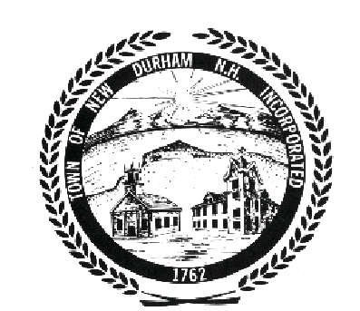
BOARD OF SELECTMEN
Public Meeting Budget Session
Agenda for Monday, October 25, 2010
New Durham Town Hall – 7 PM

- Call to Order

- Budget Review

- Election & Registration- 4140

- Financial Administration- 4150

- Parks & Recreation- 4520

- Assessing- 4152

- Legal Expenses- 4153

- Insurance- 4196

- Health & other Agencies- 4415

- Welfare- 4441

- Improvements Other Than Buildings- 4909

- Any Other Business

- Adjourn

The Board of Selectmen may enter into Non Public Session, if so voted, under
the Terms and Conditions of RSA 91-A:3 II a - e and RSA 91-A:2 I c.

